TASK 3: ASSESSMENT COMMENTARY
Respond to the prompts below (no more than 10 single-spaced pages, including prompts) by typing your responses within the brackets following each prompt. Do not delete or alter the prompts. Commentary pages exceeding the maximum will not be scored. Attach the assessment you used to evaluate student performance (no more than 5 additional pages) to the end of this file. If you submit a video work sample or a video or audio clip of feedback that contains key audio portions that cannot be clearly heard, attach a transcription of the inaudible comments (no more than 2 additional pages) to the end of this file. These pages do not count toward your page total.

1. Analyzing Student Learning
a. Identify the specific learning objectives measured by the assessments you chose for analysis.
[ The specific learning objectives I chose to focus on for this unit involves the psychomotor and cognitive domains. The cues for backhand grip of the frisbee was my psychomotor pre and post assessment, while the rules of Ultimate Frisbee were the focus of my Cognitive pre and post assessment.]
b. Provide a graphic (table or chart) or narrative that summarizes evidence of student learning for your whole class (or, if more than 30 students, group) in the psychomotor domain and at least one other domain (cognitive and/or affective). Be sure to summarize student learning for all evaluation criteria submitted in Assessment Task 3, Part D.
[ 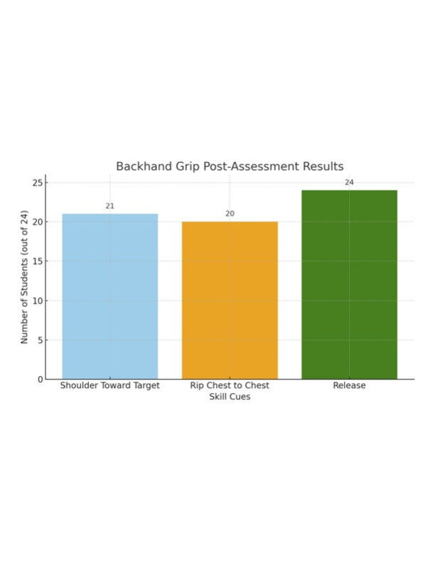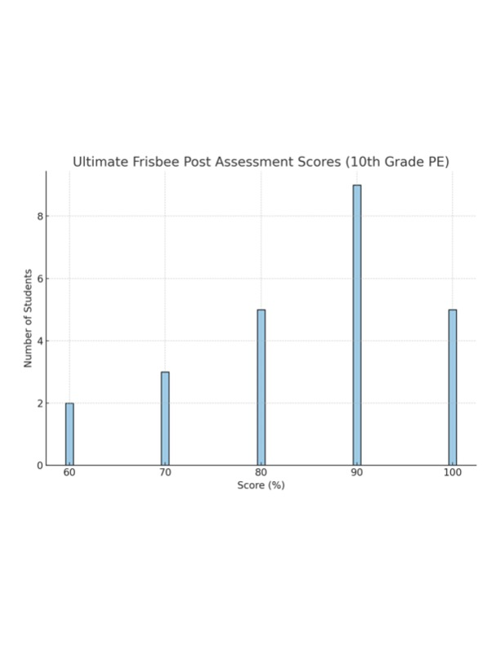 ]
c. Analyze the patterns of learning for the whole class (or group) and differences for groups or individual learners relative to competencies targeted in the psychomotor domain and at least one other learning domain (cognitive and/or affective).
[ One pattern noticed is that every student was able to demonstrate the release of the frisbee but not every student was releasing the frisbee to the best they possibly could have. This was evident when only 15 students had their shoulders pointed towards the target when releasing the frisbee.]
d. Cite direct evidence from the focus student work samples and/or the written documentation of the assessment of the psychomotor activity to support the analysis.
Consider what students understand and do well, and where they continue to struggle (e.g., strengths, weaknesses, common errors, confusions, need for greater challenge).
[ The focus students were all very understanding of the other aspects of Ultimate Frisbee that are very transferable from other invasion game like competitive sports, but the actual throwing of the frisbee was a concept that most found to be very foreign. A major common error displayed was students letting go of the frisbee on a lopsided angle instead of firm and flat. This was evident throughout my lesson two warmup for this unit.]
e. If a video work sample occurs in a group context (e.g., discussion), provide the name of the clip and clearly describe how the scorer can identify the focus student(s) (e.g., position, physical description) whose work is portrayed.
[ At the very beginning of my video, you can see me working with one of my focus students in the pink shirt. In this exchange, I am not only giving her visual demonstration of backhand grip and having her trying to replicate it, but also giving her extension suggestions to begin working on with her partner.]

2. Feedback to Guide Further Learning
Refer to specific evidence of feedback provided to the 3 focus students about their performance in the psychomotor domain and at least one other learning domain (cognitive and/or affective) to support your explanations.
- Identify the format in which you submitted your evidence of feedback for the 3 focus students. For each assessment, submit the same type of feedback (i.e., video, audio, written) for all 3 focus students. Choose up to two of the following across all assessments. (Delete choices that do not apply.)
- In video work samples (provide a time-stamp reference) or in separate video clips
- As rubrics, rating scales, or checklists with written feedback
- As a separate document file with written feedback provided to students
- In audio files
If video or audio feedback occurs in a group context (e.g., game, discussion), clearly describe how the scorer can identify the focus student (e.g., position, physical description, student quote) who is being given feedback. Submit any written feedback for all 3 focus students in one file.
[ At the five-minute mark of my video when I am giving full group discussion, you can see all three of my focus students in farm. I picked my three focus students based off levels of proficiency within the unit. My lower-level proficiency focus student can be seen wearing the brown jacket with headphones around his neck, my medium level focus student can be seen wearing the black and white striped sweater with the blonde hair. My higher proficiency level focus student can be seen working as my student volunteer demonstrator in this portion of the lesson.]
- Explain how feedback provided to the 3 focus students addresses their individual strengths and needs relative to the learning objectives measured.
[The feedback given to these three focus students are all vastly different from another. I must constantly challenge my higher-level focus student due to her athletic background and consistent willingness to go all out while in PE Class. My medium level student is hit or miss with their dedication to the lesson, and I often must encourage them to stick with the process of our unit progression. My lower-level student is not a fan of PE class, but it has been extremely rewarding being able to motivate that student and seeing them begin to express more interest in full group activity,]
- Describe how you will support each focus student to understand and use this feedback to further their learning related to learning objectives. Use of feedback can occur in a different task or lesson within the learning segment or at a later time.
[ I will support each focus student in whatever way they need me to and I will make sure as a Physical Educator that my teachings have differentiated learning geared differently towards all three of the focus students. I made sure throughout this unit that I would pull these three specifically aside and check in with them with positive feedback that they are showing me everything I want to see from them.]

3. Evidence of Language Understanding and Use
When responding to the prompt below, use concrete examples from the clip(s) and/or student work samples as evidence. Evidence from the clip(s) may focus on one or more students.
You may provide evidence of students’ language use from ONE OR MORE of the following sources:
- Video clip(s) from Instruction Task 2. Provide time-stamp references for evidence of language use.
- An additional video file named “Language Use” of no more than 5 minutes in length. Cite student language use. (This can be footage of one or more students’ language use.) Submit the clip in Assessment Task 3, Part B.
- The student work samples analyzed in Assessment Task 3. Cite language use.
4. Other written evidence of language use from the learning segment. Submit this written evidence in Assessment Task 3, Part B.
- Explain and provide concrete examples for the extent to which your students were able to use or struggled to use the
- selected language function,
- vocabulary, AND
- syntax or discourse
to develop content understandings.
[ My students struggled or shied away from the discourse I was hoping to see come out of this unit. The most evident times of this was during the box activity from lesson two as well as the modified gameplay in lesson 4. I noticed that higher proficient students would intentionally go for long balls during the game and only pass to the same couple of people. I made sure to talk to these students and let them know that I want to see everyone involved and the other students need to do a better job at communicating with their team. ]

4. Using Assessment to Inform Instruction
a. Based on your analysis of student learning presented in prompts 1b–d, describe next steps for instruction to impact student learning:
- For the whole class
- For the 3 focus students and other individuals/groups with specific needs
Consider the variety of learners in your class who may require different strategies/support (e.g., students with IEPs or 504 plans, English language learners, or students with higher/lower proficiency levels).
[I believe the next logical step if this unit were to progress beyond would be to incorporate a higher importance involving the backwards passing or possibly even formations and coming up with plays. Getting the students to have to think cognitively about a coordinated offensive and defensive attack in the game of Ultimate Frisbee would just further heighten the potential of this Ultimate Frisbee unit. ]
b. Explain how these next steps follow from your analysis of students’ learning. Support your explanation with principles from research and/or theory.
[ These next steps are a direct step up from the pre and post assessments of basic Ultimate Frisbee and could even add in the addition of a Hammer throw. Robert Pangrazi’s Dynamic PE was a massive help to figuring out what should and should not be covered in this unit! ]

