1. **Analyzing Student Learning -**

**Psychomotor Objective**

As a result of this lesson students will complete the badminton serve assessment, successfully using an underhand or low backhand serve of the shuttle to the opposite diagonal box of the net. All students must successfully do so 12 out of 21 times to pass. Each student must demonstrate stepping forward with the opposite foot of the hand that holds the racquet, contacting the shuttlecock with the strings of the racquet below the serving elbow, and follow through with the shuttlecock.

**HPE 240 Data**

**Practice Product Results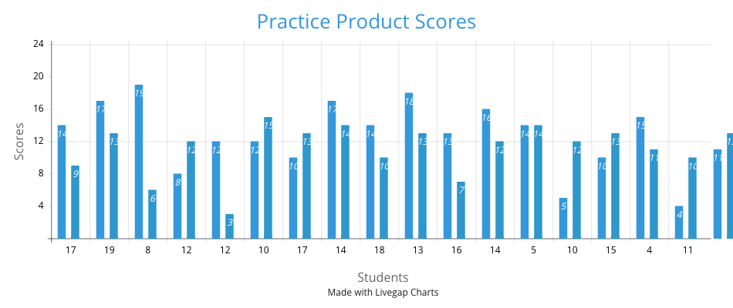Practice Process Results**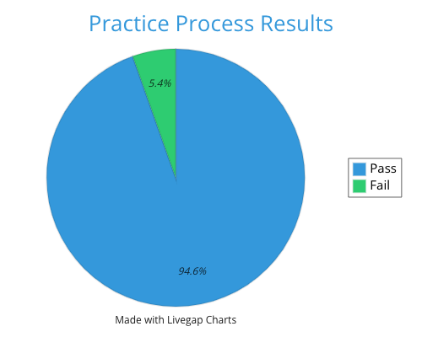

**Product Final Score:**

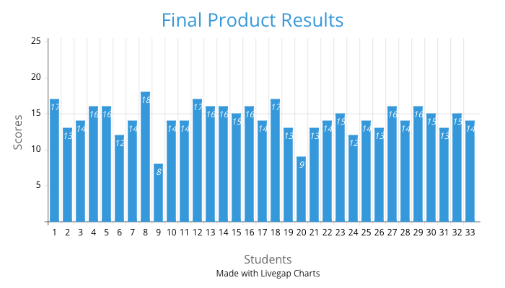

**Process Final Score:**

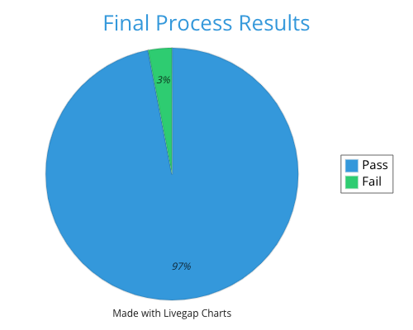

**Whole Class Analysis:**

Overall, the data indicates a significant improvement in the students' performance from the practice assessment to the final assessment. There were 12 students who did not achieve a score of 12 out of 21 to pass this assessment in the practice assessment. In the final assessment, that number dropped all the way down to just 2 students who did not reach the passing threshold of 12 out of 21. There was also an increase in process cues being shown. The students improved from a full display rate of cues at 94.6% in the practice to 97% in the final. I attribute this increase in success to the students putting in substantial practice with badminton serving in between the practice and final assessments. Some students specifically told me that they put in practice by going to the tennis courts to simulate a badminton serve.

**Focus Students:**

Student 31 is one student I focused on during the practice assessment. This student was a part of the group that initially did not meet the requirement of 12 to pass. What I had noticed with this student was that they would consistently use the underhand serve and hit the shuttle exceedingly high in the air. A large part of this assessment was having the right mix of power and accuracy and not hitting the shuttle above the 24 inches of leeway above the net. This student used this to practice going forward and pass the final assessment.

Student 33 was another student I chose to focus on for this assessment. When going through the practice assessment, I noticed that this student was having a tough time finding success with the underhand serve. I noticed this early in her practice assessment and went to the student and suggested using the low backhand serve instead. The student decided to take my advice and when I got to this student again after walking around the other assessment stations, this student was finding immense success. This student was able to salvage their practice attempt, and I intentionally wanted to see what this student would do for the final assessment. During the final assessment, this student used the low backhand serve again and passed with more ease.

Student 9 was an interesting case for this assessment. This student demonstrated all cues and passed the practice assessment with the minimum score of 12. However, when it came time to take the final assessment, this student only received an 8. When talking to this student, they referenced they felt a lot of nerves going into the final assessment knowing that they had a grade on the line. They also mentioned a lack of practice and preparation for the decline in performance. This student did eventually pass this assessment on makeup day, which will not be reflected in this data.

**Feedback**:

For students 31 and 33, I feel good about the feedback that I gave them and believe I steered them on the right path of success. I knew these students would be capable of passing, which is why I emphasized my focus on these students and provided them with the feedback that I did. Some other examples of feedback that I gave to other students included reset and take a second to relax before resuming the assessment. This would have been beneficial for student 9 when they were feeling nerves during the assessment. Another example of feedback that benefited a student came with student 21. This student was able to pass the final assessment without displaying any cues. This student was able to pass the assessment without stepping with their foot, and they held the shuttle lower than the strings. I suggested to this student to hold the shuttle by the flared-out part of the shuttle. This student was then able to find more success using my corrective feedback. For other examples of feedback there is a 10-minute sample of my teachings on my web page.

Evidence of Understanding Language:

The students demonstrated understanding of the language throughout this lesson. I made sure to walk around each station and check in with every student. I would ask the students if they understood all the instructions and were feeling good about the assessment. The students made me aware that they did have trouble understanding the landing target zone of the shuttles. I then went into further detail that if the shuttle hits anywhere in the box that is designated by the hula hoops and mark. The students had a much better understanding when I demonstrated this in the final assessment which is shown in the teaching video sample.

**Use of Assessment to Inform Instruction:**

This assessment was effective in informing instruction in numerous ways. The most effective being the major increase of passing students from 22 students passing in the practice to 35 students passing in the final. This jump proves that the students took away from the practice instruction and decided to do more to achieve a passing grade. There was even more success found in the process data results for this assessment. The students were able to take away from my cues demonstration successfully, as shown in my teaching video. Most of the students were able to follow the cues and display them to their assessors. At the end of the final assessment, only one student did not achieve a passing grade for their process portion. This student was still able to pass the assessment. Based off the significant increase of passing scores from the practice test to the final test. It would be beneficial for future students in this assessment to track their progress over the month in between the tests and give that back to me. I had a few students tell me they did engage in practice through use of tennis courts and hitting towards a wall. Knowing this now, I strongly suggest students who did not achieve a passing grade in the practice to engage in a similar practice routine. Once the final assessment is completed, I would collect this data from the participating students and be able to use that going forward as proof of learning from the instruction in this assessment.